**ePrescribing for Controlled Substances (EPCS) at OptumRx Home Delivery Pharmacy:**

**Updated 1/30/2020:** Includes information on grace period and exceptions

**EPCS Overview**

**What is EPCS?**

* Electronic Prescriptions for Controlled Substances (EPCS), is the emerging industry **standard to ensure safe and proper prescribing of narcotics, opioids and other** controlled substances. Physicians must be EPCS enabled in order to e-prescribe one of these medications.

**How does EPCS address prescription theft & fraud?**

* The US Drug Enforcement Administration (DEA) and state Boards of Pharmacy have worked together to create programs and regulations to deter abuse/misuse.
* EPCS technology requires a 2-factor authentication of prescribers within the Electronic Health Record/Electronic Medical Record (EHR/EMR), thereby improving security standards, improving prescription safety, and reducing errors.

**OptumRx and EPCS**

## What are the new OptumRx home delivery pharmacy requirements for EPCS?

## Effective January 1, 2020, OptumRx home delivery pharmacy will begin a phased approach to requiring all prescriptions for controlled substances to be prescribed via EPCS.

## A grace period is in place from January 1, 2020 to February 29, 2020 in which prescriptions will be filled regardless of how they are submitted (hard copy, fax or phone).

## You will receive a notification when the prescription has been filled and ask that you align to prescribing via EPCS by March 1, 2020.

**Exemptions do apply. Please see table below for details:**

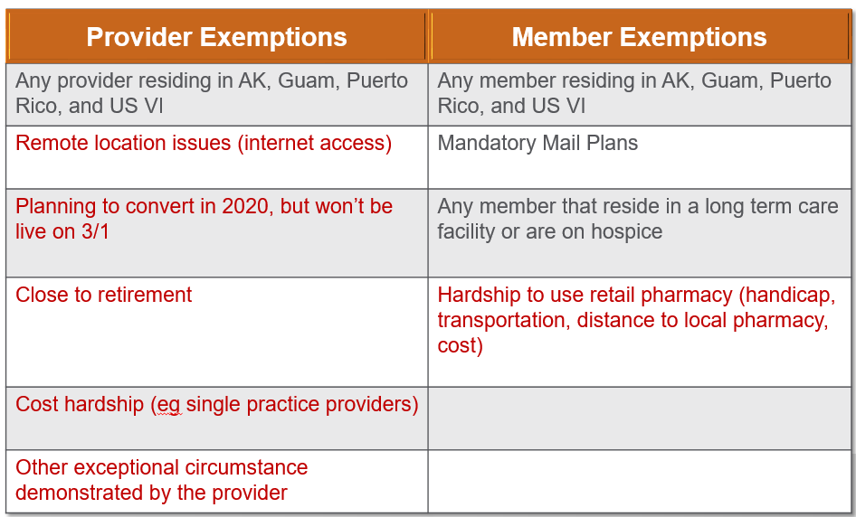

Grey = No further contact is required with OptumRx

Red = Requires further contact with OptumRx (see below for details)

* **Any exemption in grey is already auto programmed into our system, no contact with OptumRx** **home delivery pharmacy** is necessary for a provider or member that meets one of those criteria
* Exemptions in Red do require contact with an OptumRx home delivery pharmacy representative to log your exemption if you qualify. You may contact [EPCSquestions@optum.com](mailto:EPCSquestions@optum.com) if you are a provider and believe one of these apply to you.
* If you are in a state that already requires EPCS and have an exemption logged with the state, you may also email [EPCSquestions@optum.com](mailto:EPCSquestions@optum.com) to have your exemption logged at OptumRx home delivery pharmacy.
* Members may call the number on the back of their insurance card to ensure an exemption is logged if they have a hardship to use retail pharmacy. Impacted members have received communications regarding this change.

**EPCS Requirements and Regulations**

**What are the requirements for Providers to obtain and use EPCS technology?**

* The provider must register with the DEA and obtain a DEA number in order to be able to prescribe controlled substances.
* The provider’s EHR/EMR or technology must be a certified product by a third party auditor or a certification body (ensuring the proper creation, signing, and refilling of controlled substance prescriptions).
* EPCS technology security protection must have the 2-factor authentication -- and identity verification -- in place to meet national standards.

**State Board of Pharmacy Regulations**

* Multiple states already require controlled substances to be sent electronically, and many have legislation in place that will be enacted soon. Please reach out to your state board if you have any questions for your state.

**Federal Regulations**

* October 24, 2018, H.R. 6 (the “SUPPORT Act”) was signed into law. It mandates that, with limited exemptions, ePrescribing will be required for controlled substance prescriptions for MAP-D and Part D plan members effective January 1, 2021. All Exemptions offered by OptumRx align with the CMS SUPPORT Act.

**Member Experience**

## How many members will be impacted?

* Based on the recent data pull containing 12 months of home delivery claims, 130,000* members will be impacted by the program.

*Note: this is just an estimate, and the actual impacted number may be higher or lower depending upon changes in utilization.

**What will be the home delivery pharmacy process after March 1, 2020 when receiving paper, fax or telephone prescriptions for controlled substances?**

* An outreach will be made to the provider to obtain an electronic prescription
* If no response is received from the provider, we will inform the patient that their prescription will not be filled. OptumRx home delivery pharmacy will return hard copy prescriptions to patients and help to find a local in network pharmacy when needed.

**If you have additional questions:**

**Contact the OptumRx EPCS Email Hotline**

[EPCSquestions@optum.com](mailto:EPCSquestions@optum.com)