**Exemptions to the OptumRx home delivery pharmacy EPCS requirement do apply.   
Please see table below for details:**

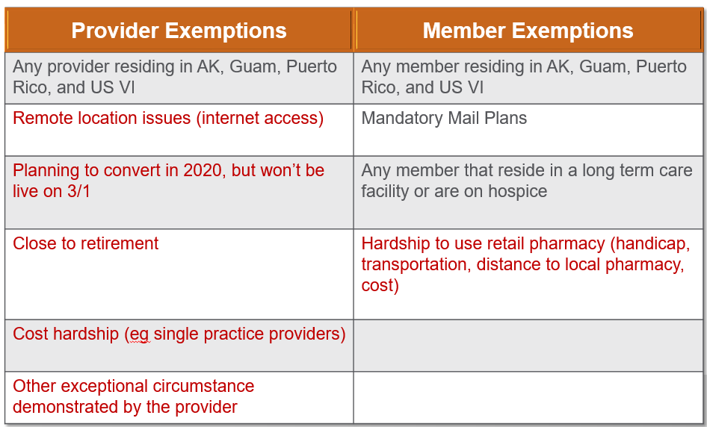

Grey = No further contact is required with OptumRx

Red = Requires further contact with OptumRx (see below for details)

✓  **Any exemption in grey is already auto programmed into our system, no contact with OptumRx** **home delivery pharmacy** is necessary for a provider or member that meets one of those criteria.

✓  Exemptions in Red do require contact with an OptumRx home delivery pharmacy  representative to log your exemption if you qualify.  You may contact [EPCSquestions@optum.com](mailto:EPCSquestions@optum.com) if you are a provider and believe one of these apply to you.

✓  If you are in a state that already requires EPCS and have an exemption logged with the state, you may also email [EPCSquestions@optum.com](mailto:EPCSquestions@optum.com) to have your exemption logged at OptumRx home delivery pharmacy.

✓  Members may call the number on the back of their insurance card to ensure an exemption is logged if they have a hardship to use retail pharmacy.  Impacted members have received communications regarding this change.